UNITY TRUST MODEL PRIMARY SCHOOL P. TWO
LITERACY 0NE NOTES 2016
TERM III
Week 2
Lesson 1
THEME: MEASURES
SUB THEME: WEATHER
Weather
What is weather?
Weather is the state of atmosphere of a place for a short period of time.
Elements/ factors / components/ aspects of weather
- Rainfall - wind - Temperature
- Sunshine - cloud cover
Name these types /conditions of weather
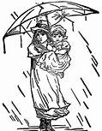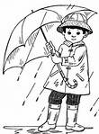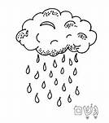 | 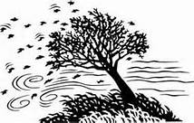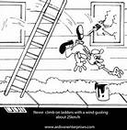
Rainy | windy
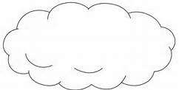 | 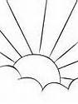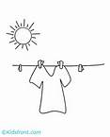
Cloudy | sunny
Types of weather

- Rainy weather
- Sunny weather
- Cloudy weather
- Windy weather

Lesson 2
Effects and management of weather
Uses of rainfall
It gives us rain water.
It waters plants.
It cools the earth.
Dangers of too much rainfall
It causes floods.
It destroys plants.
It destroys houses.
It destroys roads.
It leads to soil erosion.
It causes landslides.
It kills animals and people.
It spreads diseases like cholera.
Uses of sunshine
It gives us light.
It dries our clothes.
It gives us vitamin D.
It dries seeds.
For solar electricity
Dangers of too much sunshine
It dries crops.
It causes drought.
It dries water bodies.
It brings sweat
It kills animals.
Lesson 3
Uses of wind
Wind is moving air.
It dries clothes.
It takes away bad smell.
It moves wind mills, boats and airplanes.
For flying kites and balloons.
For winnowing.
Dangers of wind
It destroys houses.
It spreads diseases.
It causes accidents.
It destroys crops.
It causes soil erosion.
How to manage weather
Rainy weather
-By wearing gum boots.
-By wearing sweaters and rain coats.
-By using umbrellas.
-By planting short grass.
-By building shelter.
Sunny weather
By wearing sun glasses.
By wearing light clothes
By using umbrellas
By wearing hats
Windy weather
Planting trees to act as wind breaks
Week 3
Lesson 1
TOPICAL QUESTIONS
1.How do we call the change of atmosphere of a place for a short period of time?
2.Draw and name four types of weather.
3. How is sunshine useful in the environment?
4.Mention at least two dangers of too much rainfall.
5.How do people manage the following types of weather?
a) rainy weather
b) sunny weather
c) windy weather

Lesson 2
SUB THEME: Time
Telling the time of the day
Using ;
Artificial ways; watches and clock faces
Natural ways; cocks and shadows of objects
7:00 am, 5:00 pm, 1:00 pm
a) The days of the week

- Sunday - Monday
- Tuesday - Wednesday
- Thursday - Friday
- Saturday

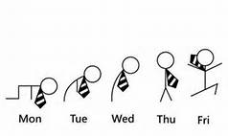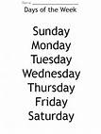
b) What is the last day of the week?
Saturday is the last day of the week.
ii) Which day of the week comes after Tuesday?
Wednesday comes after Tuesday.
iii) Sunday is the first day of the week.
iv) On which two days don’t we come to school?
- Saturday b ) Sunday
Write in full.
a) Sun. - Sunday
b) Wed. - Wednesday
c) Sat. – Saturday
lesson 3
The calendar
1. There are twelve months in a year.
2. A common year has 365 days.
3. A leap year has 366 days.
4. A leap year comes everyafter 4 years.
5. It becomes a leap year when February has 29 days instead of 28days.
(Teacher and the learners try to count the last and next leap year)
Months Days
1. January 31 days
2. February _______
3. March _______
4. April _______
5. May _______
6. June _______
7. July 31 days
8. August _______
9. September 30 days
10. October _______
11. November _______
12. December _______
(Tr. will teach the children how to count the days and month of the year on their hands.)
1. What is the fifth month of the year?
May
2. Which month has the fewest days?
February
3. December is the last month of the year.
4. Name any two months with 31 days.
January / March / May/ July / August / October / December
Week 4
Lesson1
Important events in the year
Event Date
1. New year’s day 1st Jan
2. Liberation day 26th Jan
3. Women’s day 8th March
4. Good Friday March / April
5. Easter day “
6. Easter Monday “
7. Labour day 1st May
8. Martyrs day 3rd June
9. Heroes’ day 9th June
10. Independence day 9th October
11. Christmas day 25th December
12. Boxing day 26th December
Christmas day celebrations
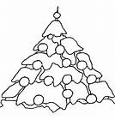 | 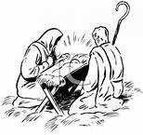 | 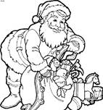 | 
Activity
- What do we remember on these days as we celebrate them;
- Good Friday
- Easter Sunday
- Martyrs day
- Christmas day
- Heroes day

Lesson 2
TOPICAL QUESTIONS
- How do people in your area tell time?
- Write the sixth month of the year.
- When do people celebrate the birth of Jesus?
- What happens on 9th October every year?
- Write the following words in full.
- Sat b)Wed c) Sun

Lesson 3
SUB THEME; Seasons
We have two seasons
1. Wet season
2. Dry season
Activities done in the wet season
- Planting - Weeding
- Pruning - Thinning - Transplanting
-Harvesting rain water( using tanks, jerrycans,drums,buckets,pots,saucepans etc)

TOOLS USED IN GROWING CROPS
Names | Garden tool | Uses
axe | 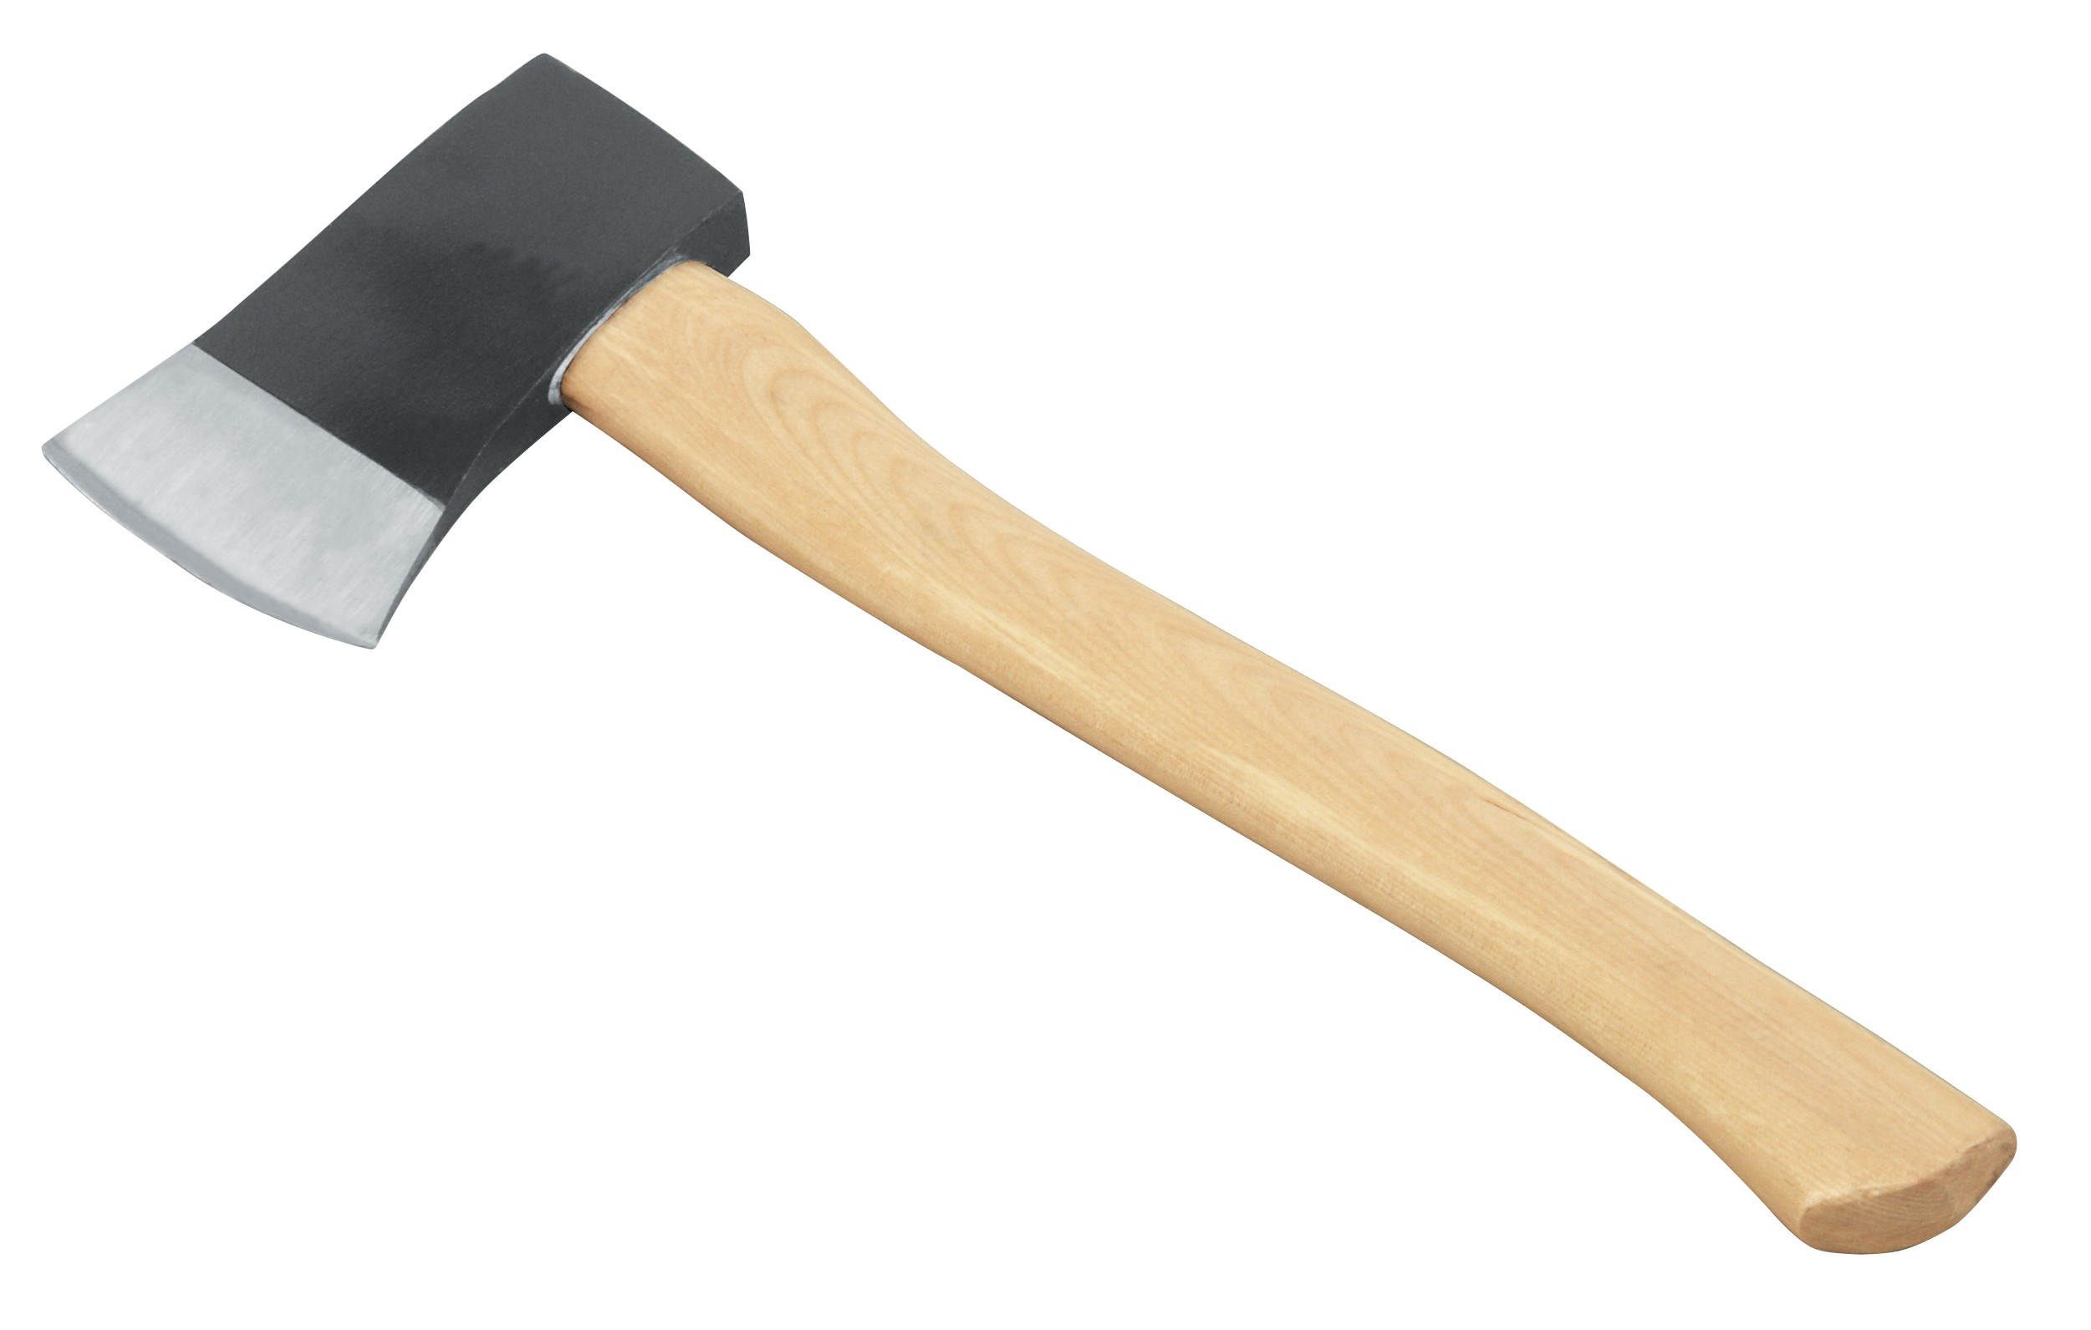 | For cutting big trees  For splitting wood
Hoe | 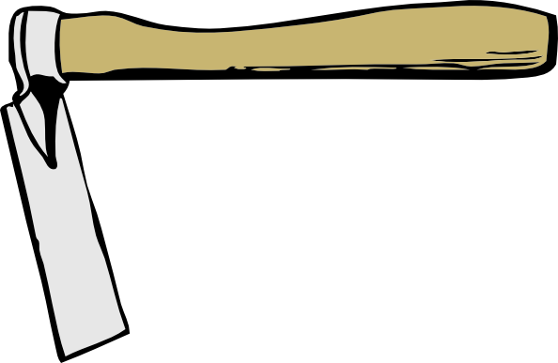 | For digging,weeding  For harvesting root crops
slasher | 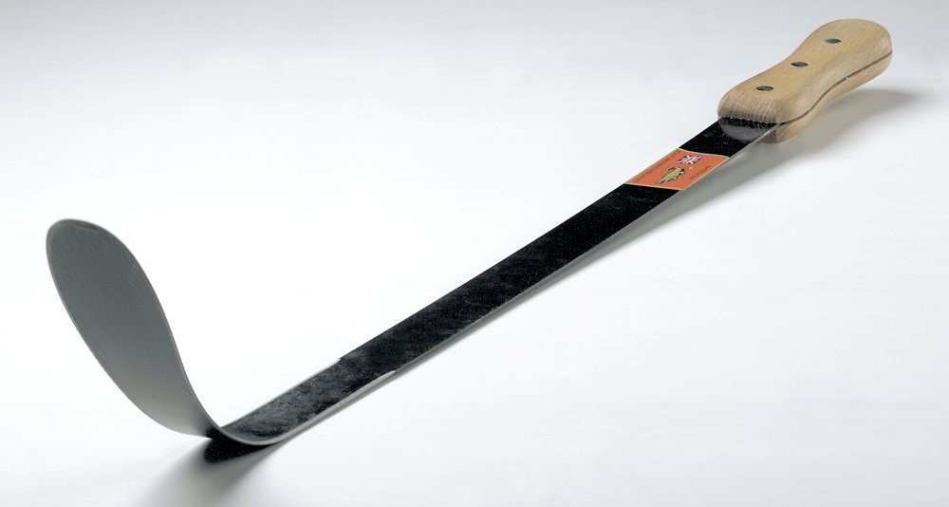 | For slashing grass
Panga | 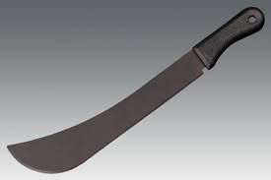 | For cutting small trees  For harvesting some crops
Watering can | 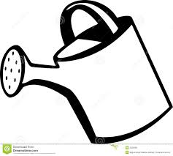 | For watering crops
knife | 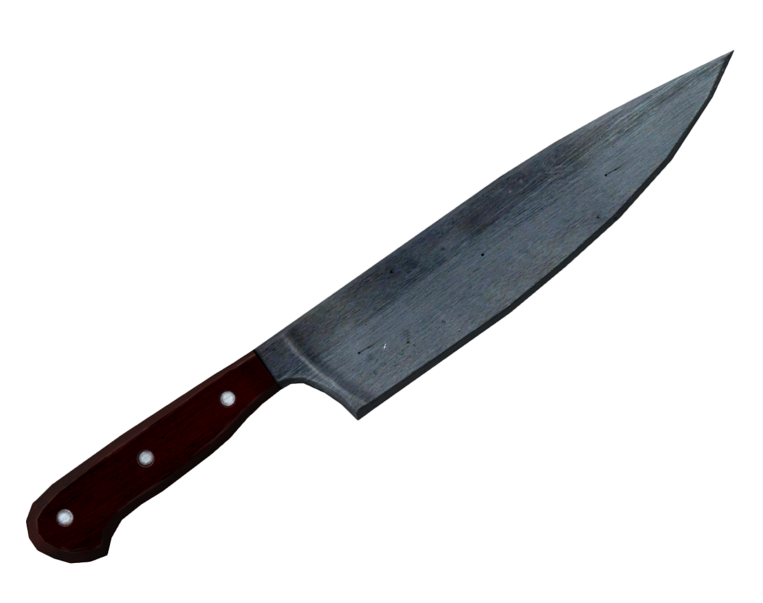 | For harvesting some crops
basket | 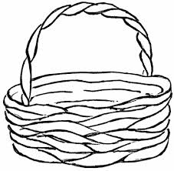 | For carrying harvested crops.  For carrying seeds
spade | 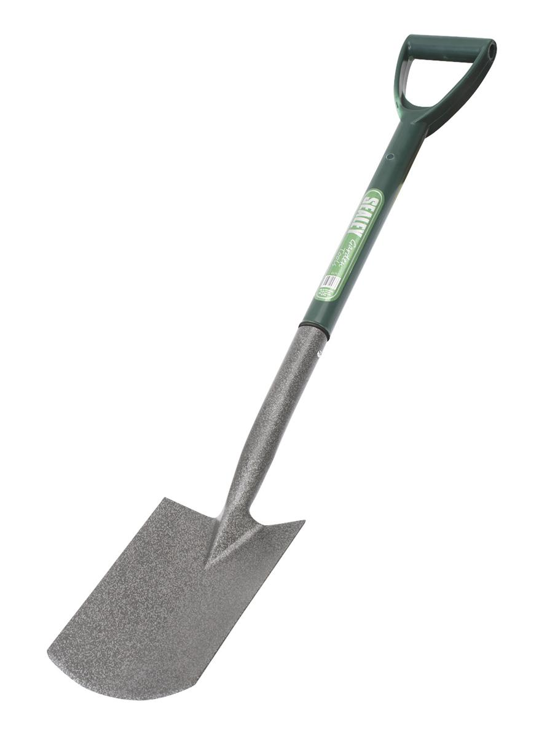 | For loading soil and manure
rake | 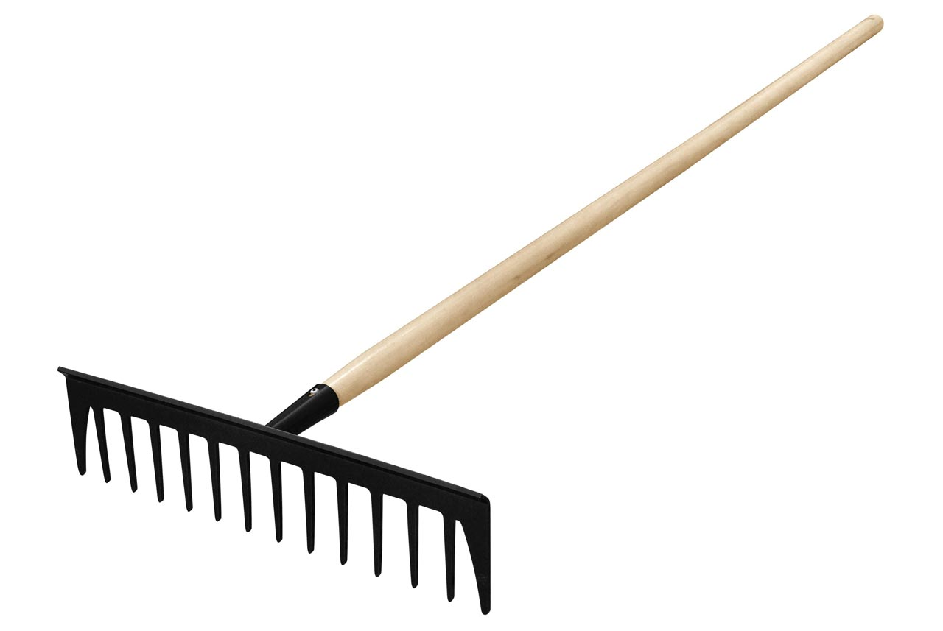 | For collecting rubbish  For spreading manure  For leveling soil
wheelbarrow | 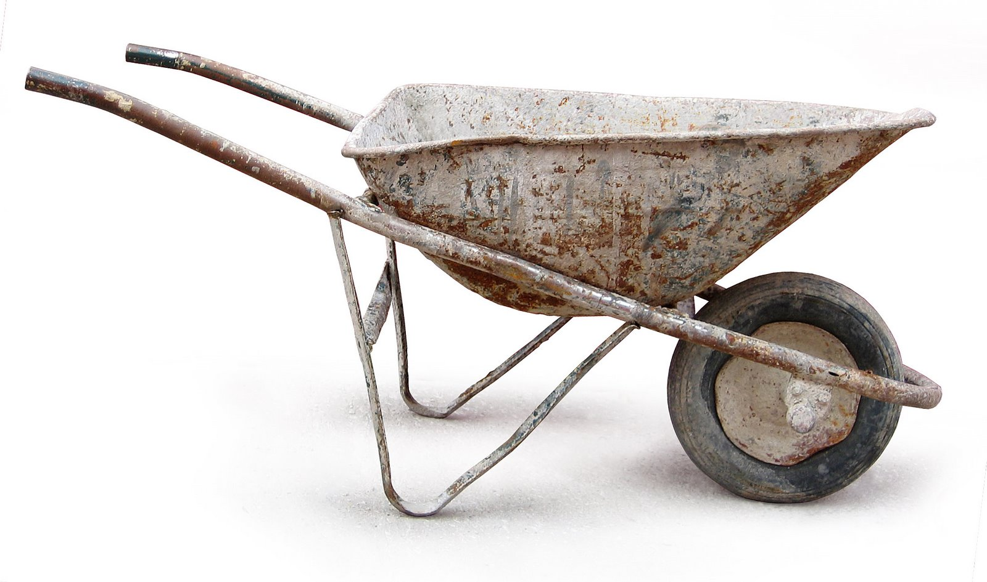 | For carrying soil  For carrying manure  For carrying garden tools  For carrying seedlings

Week 5
MID TERM EXAMINATIONS

Week 6
Lesson 1

a) What is planting?
Planting is the putting of seeds in the ground.
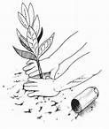 | 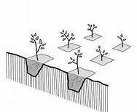 | 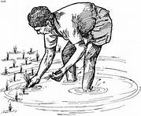 | 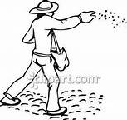

b) What is weeding?
Weeding is the removal of unwanted plants from the garden.
N.B: Unwanted plants are called weeds.
People weeding the garden
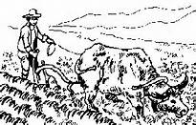 | 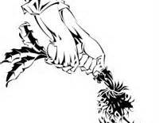
Weeding using an ox | Uprooting the weed

Wanted plants in the garden are called crops.
c) What is pruning?
Pruning is the cutting off of unwanted branches and old parts of a plant.
Someone pruning the crops
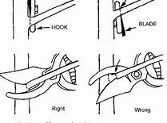 | 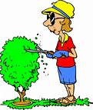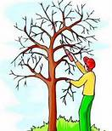
Pruning | Pruning
d) What is thinning?
Thinning is the removal of some plants to give space to the others to grow.
Someone thinning the crops
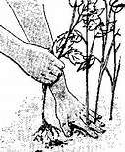 | 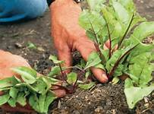 | 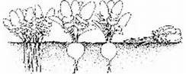
Thinning the crops |  | Non thinned and a thinned area in the garden

Lesson 2
e) What is transplanting?
This is the transfer of seedling from the nursery bed to the main garden.
A nursery bed is a small piece of land where seeds are first planted . e.g cabbage seeds.
Someone transplanting crops
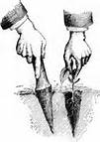 | 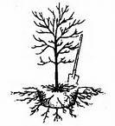 | 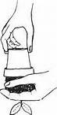
Transplanting
The dry season
Activities done in the dry season
- Watering plants - Drying seeds
- Sheltering crops - Harvesting
- clearing land - Marketing
- mulching

f) What is harvesting?
This is the removal of ready crops from the garden.
Someone harvesting
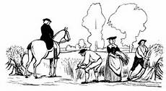 | 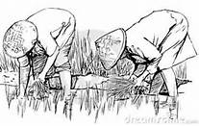 | 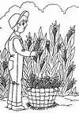
Harvesting

Lesson 3
g) What is watering plants?
- This is the way of adding more water to the soil in a dry season.
- This is the spraying of water onto the plants during the dry season.

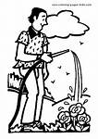 | 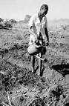 | 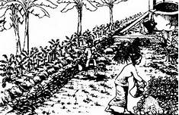 | 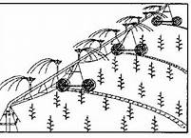
c) Drying seeds
This is when seeds are put out under sunshine to dry.
Drying seeds
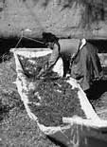 | 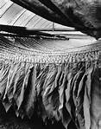 | 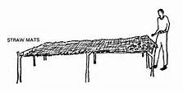 | 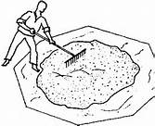
Drying seeds | Curing tobacco | Drying on rack | Drying seeds too on a mat

d) Sheltering crops
This is when you cover top of a nursery bed to protect the seedling from bad weather, animals/pests.
Sheltering crops
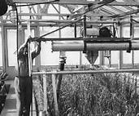 | 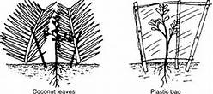
e) Winnowing
The removal of husks from the seeds using wind

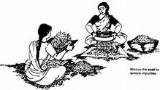 | 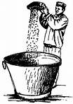 | 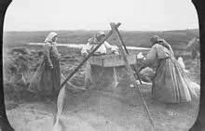

Week 7
Lesson 1 & 2
Practical lesson
Planting, watering, sheltering, thinning

Lesson 3
TOPICAL QUESTIONS
1. Name any two activities done in the wet season.
Ploughing / planting / weeding / thinning /pruning /transplanting
2. What are weeds?
Weeds are unwanted plants in the garden.
3. Transplanting is the transfer of seedlings from a nursery bed to the main garden.
4. What is a nursery bed?
Is a small piece of land where seeds are first planted?
5. List down any three activities in the dry season.
1. Harvesting 2. Drying seeds
3. Watering plants
6. Why are plants sheltered?
To prevent direct sunlight
7. Why do we water plants?
To keep them healthy
The end

